TicketBookingApp:

CODE:

App.js:

import React, { useState } from 'react';
import GuestPage from './GuestPage';
import UserPage from './UserPage';
function App() {
const [isLoggedIn, setIsLoggedIn] = useState(false);

const handleLogin = () => {
setIsLoggedIn(true);
};
const handleLogout = () => {
setIsLoggedIn(false);
};
return (
<div style={{ textAlign: 'center', marginTop: '100px' }}>
{isLoggedIn ? (
<UserPage onLogout={handleLogout} />
) : (
<GuestPage onLogin={handleLogin} />
)}
</div>
);
}
export default App;

GuestPage.js:

import React from 'react';
function GuestPage({ onLogin }) {
return (
<div>
<h1>Please sign up.</h1>
<br />
<button onClick={onLogin}>Login</button>
</div>
);
}
export default GuestPage;

GuestPage.js:

import React from 'react';
function UserPage({ onLogout }) {
return (
<div>
<h1>Welcome back</h1>
<br />
<button onClick={onLogout}>Logout</button>
</div>
);
}
export default UserPage;

index.js:

import React from 'react';
import ReactDOM from 'react-dom/client';
import App from './App';

const root = ReactDOM.createRoot(document.getElementById('root'));
root.render(<App />);

Outputs:

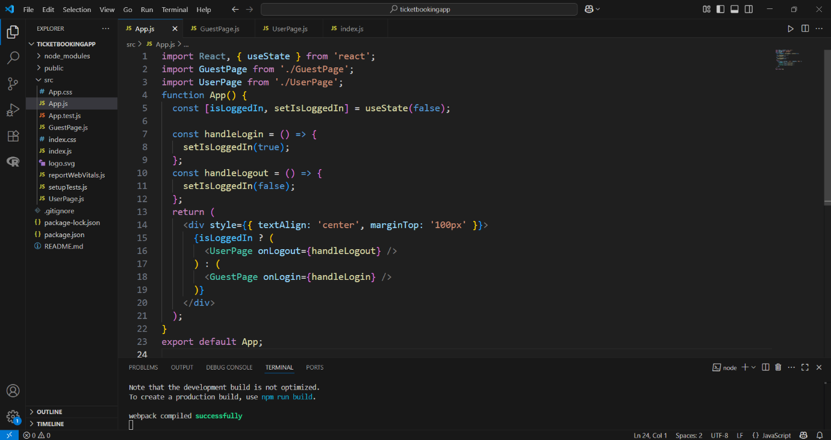

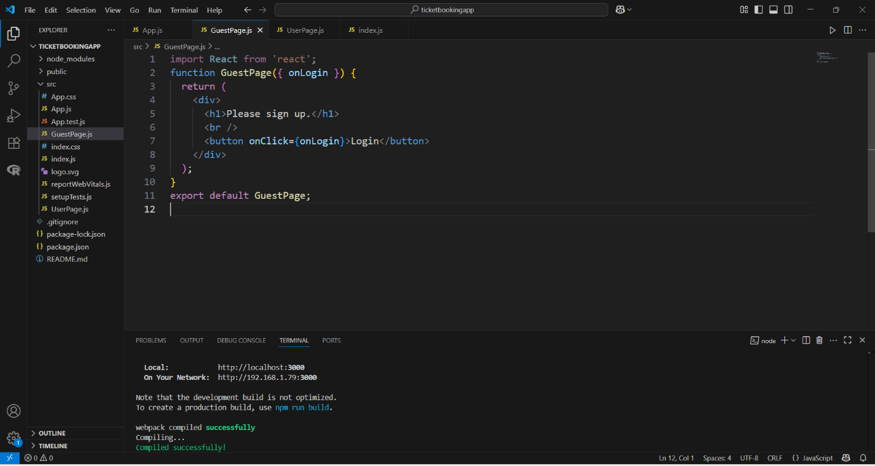

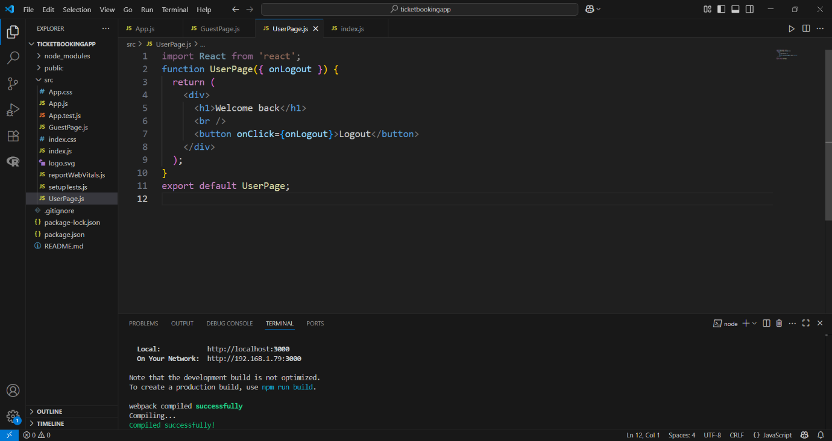

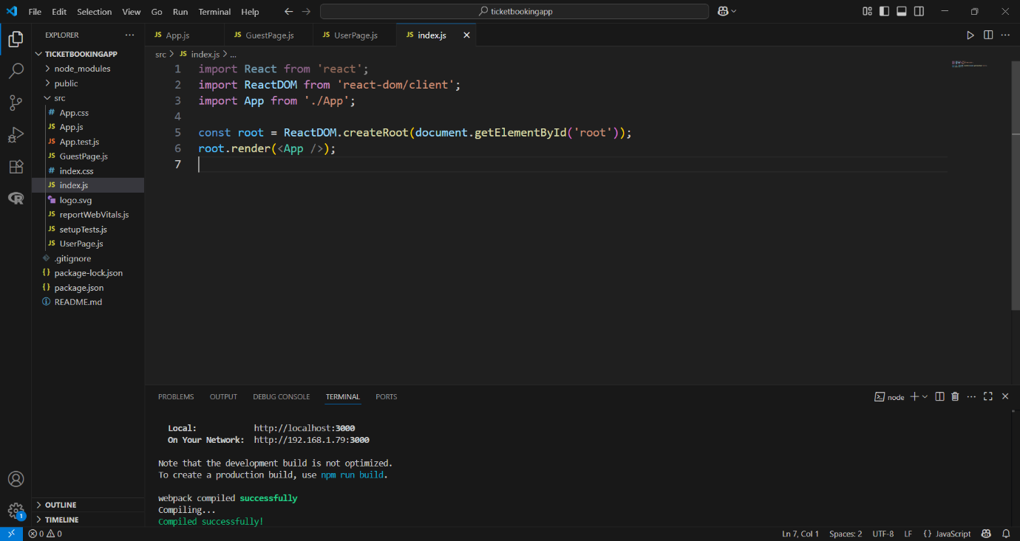

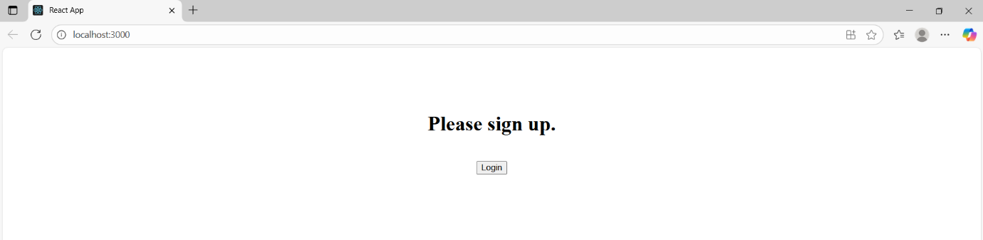

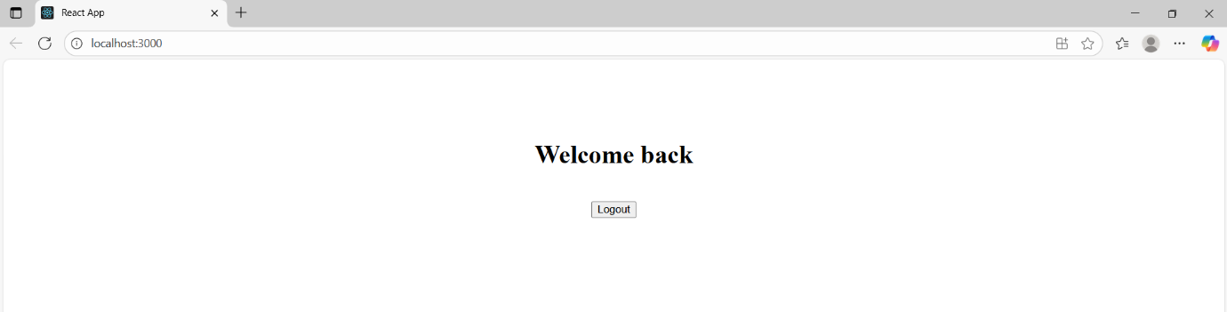

Cricketapp:

CODE:

App.js:

// src/App.js
import React from 'react';
import ListofPlayers from './components/ListofPlayers';
import IndianPlayers from './components/IndianPlayers';

function App() {
const flag = true; // Change to false to test IndianPlayers

return (
<div className="App">
{flag ? <ListofPlayers /> : <IndianPlayers />}
</div>
);
}

export default App;

ListofPlayers.js:

// src/App.js
import React from 'react';
import ListofPlayers from './components/ListofPlayers';
import IndianPlayers from './components/IndianPlayers';

function App() {
const flag = true; // Change to false to test IndianPlayers

return (
<div className="App">
{flag ? <ListofPlayers /> : <IndianPlayers />}
</div>
);
}

export default App;

IndianPlayers.js:

// src/components/IndianPlayers.js
import React from 'react';

const IndianPlayers = () => {
const team = ['Sachin1', 'Dhoni2', 'Virat3', 'Rohit4', 'Yuvaraj5', 'Raina6'];

const oddTeam = team.filter((_, i) => i % 2 === 0);
const evenTeam = team.filter((_, i) => i % 2 !== 0);

const [first, third, fifth] = oddTeam;
const [second, fourth, sixth] = evenTeam;

const T20players = ['Mr. First Player', 'Mr. Second Player', 'Mr. Third Player'];
const RanjiPlayers = ['Mr. Fourth Player', 'Mr. Fifth Player', 'Mr. Sixth Player'];
const allMerged = [...T20players, ...RanjiPlayers];

return (
<div>
<h2>Odd Players</h2>
<ul>
<li>First : {first}</li>
<li>Third : {third}</li>
<li>Fifth : {fifth}</li>
</ul>
<hr />
<h2>Even Players</h2>
<ul>
<li>Second : {second}</li>
<li>Fourth : {fourth}</li>
<li>Sixth : {sixth}</li>
</ul>
<hr />
<h2>List of Indian Players Merged:</h2>
<ul>
{allMerged.map((player, index) => (
<li key={index}>{player}</li>
))}
</ul>
</div>
);
};

export default IndianPlayers;

Outputs:

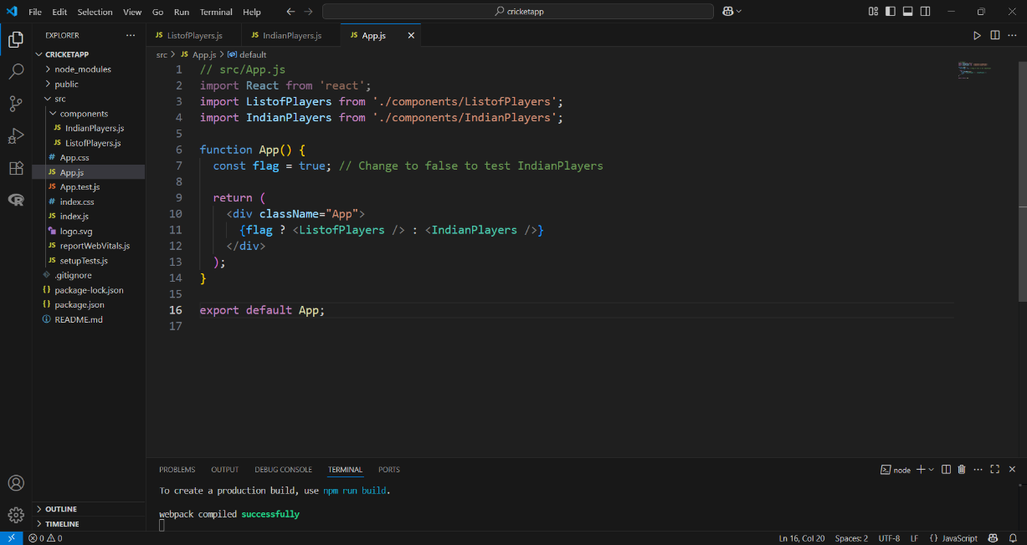

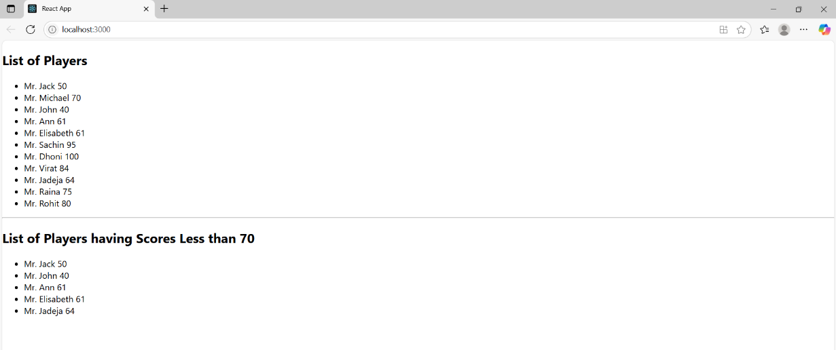

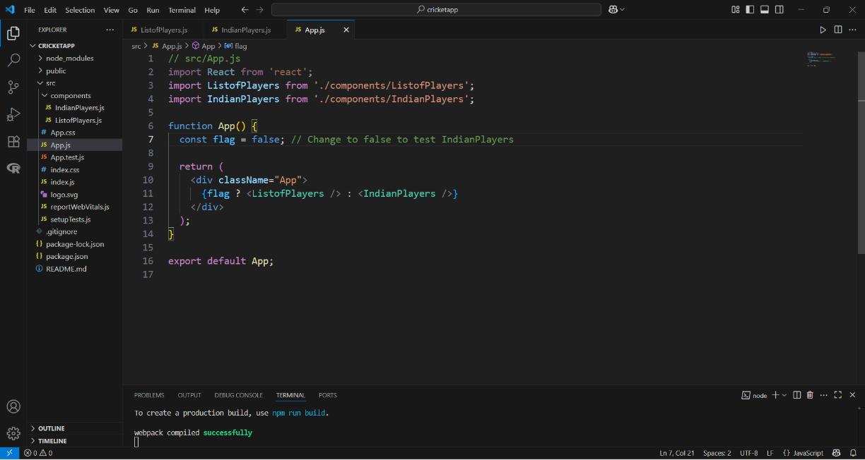

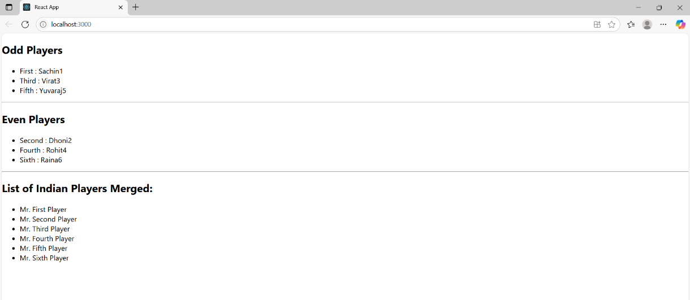

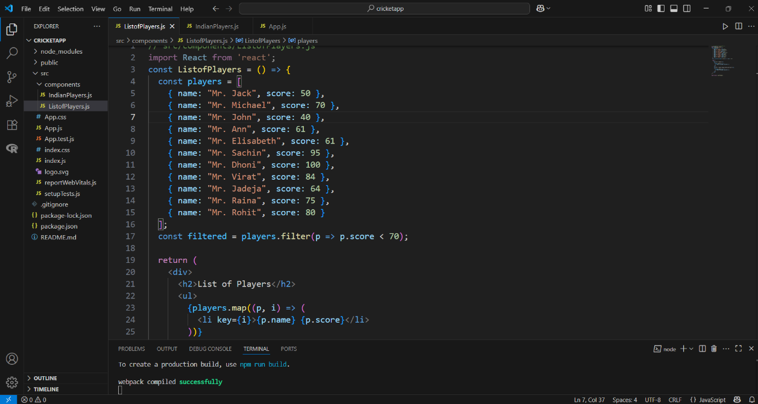

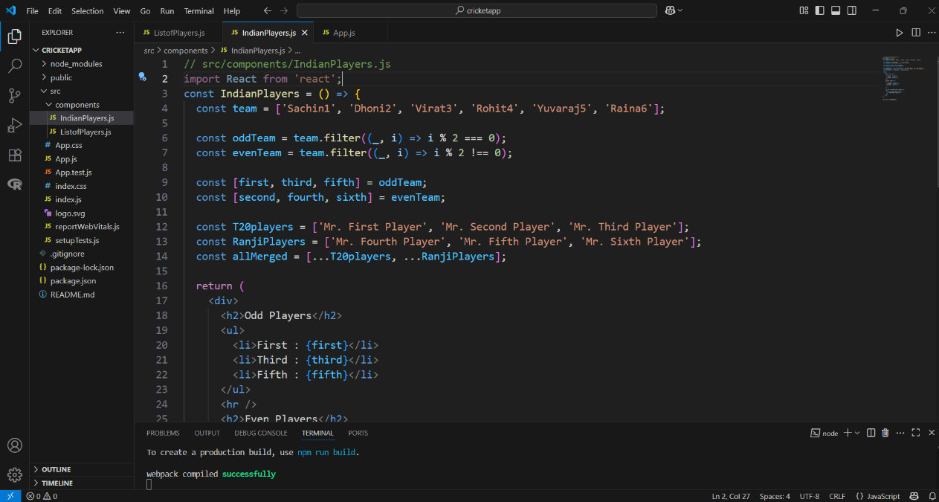

BloggerApp:

CODE:

App.js:

import React from 'react';
import BookDetails from './components/BookDetails';
import BlogDetails from './components/BlogDetails';
import CourseDetails from './components/CourseDetails';
import { books } from './data/books';
import { blogs } from './data/blogs';
import { courses } from './data/courses';
import './App.css';

function App() {
return (
<div className="container">
<div className="section">
<CourseDetails courses={courses} />
</div>
<div className="section">
<BookDetails books={books} />
</div>
<div className="section">
<BlogDetails blogs={blogs} />
</div>
</div>
);
}

export default App;

App.css:

/* -------------------- */
/* Global & Container */
/* -------------------- */

body {
font-family: Arial, sans-serif;
margin: 0;
padding: 0;
}

.container {
display: flex;
justify-content: space-around;
padding: 50px;
}

/* Each column/section */
.section {
padding: 0 40px;
width: 30%;
}

/* Green vertical line between sections (not on the first one) */
.section:not(:first-child) {
border-left: 4px solid green;
}

/* Section Headings like Course Details, Book Details, Blog Details */
.section-title {
font-size: 28px;
font-weight: bold;
margin-bottom: 25px;
}

/* -------------------- */
/* Course Details */
/* -------------------- */

.course-item {
margin-bottom: 30px;
}

.course-name {
font-size: 30px;
font-weight: bold;
margin: 0 0 18px 0;
}

.course-date {
font-size: 16px;
font-weight: bold;
margin: 0;
}

/* -------------------- */
/* Book Details */
/* -------------------- */

.book-item {
margin-bottom: 25px;
}

.book-name {
font-size: 16px;
font-weight: bold;
margin: 8px 0 4px;
}

.book-price {
font-size: 14px;
font-weight: 600;
margin-top: 20px;
}
.book-content {
padding-left: 38px;
}

/* -------------------- */
/* Blog Details */
/* -------------------- */

.blog-item {
margin-bottom: 30px;
}

.blog-title {
font-size: 26px;
font-weight: bold;
margin: 20px 0 8px;
}

.blog-author {
font-size: 12px;
font-weight: bold;
margin: 20px 0 6px;
}

.blog-content {
font-size: 12px;
margin: 18px 0;
}

CourseDetails.js:

import React from 'react';

function CourseDetails({ courses }) {
return (
<div>
<h2 className="section-title">Course Details</h2>

{courses.map((course, index) => (
<div className="course-item" key={index}>
<div className="course-name">{course.name}</div>
<div className="course-date">{course.date}</div>
</div>
))}
</div>
);
}

export default CourseDetails;

Courses.js:

export const courses = [
{ name: "Angular", date: "4/5/2021" },
{ name: "React", date: "6/3/2021" }
];

BookDetails.js:

import React from 'react';
const BookDetails = ({ books }) => {
return (
<div>
<h2 className="section-title">Book Details</h2>
<div className="book-content">
{books.map((book) => (
<div key={book.id} className="book-item">
<h3 className="book-name">{book.bname}</h3>
<p className="book-price">{book.price}</p>
</div>
))}
</div>
</div>
);
};
export default BookDetails;
Books.js:

export const books = [
{ id: 101, bname: 'Master React', price: 670 },
{ id: 102, bname: 'Deep Dive into Angular 11', price: 800 },
{ id: 103, bname: 'Mongo Essentials', price: 450 },
];

BlogDetails.js:

import React from 'react';

const BlogDetails = ({ blogs }) => {
return (
<div>
<h2 className="section-title">Blog Details</h2>
{blogs.map((blog, index) => (
<div key={index} className="blog-item">
<h3 className="blog-title">{blog.title}</h3>
<p className="blog-author">{blog.author}</p>
<p className="blog-content">{blog.content}</p>
</div>
))}
</div>
);
};

export default BlogDetails;

BlogDetails.js:

export const blogs = [
{
title: 'React Learning',
author: 'Stephen Biz',
content: 'Welcome to learning React!',
},
{
title: 'Installation',
author: 'Schwezdenier',
content: 'You can install React from npm.',
},
];

Outputs:

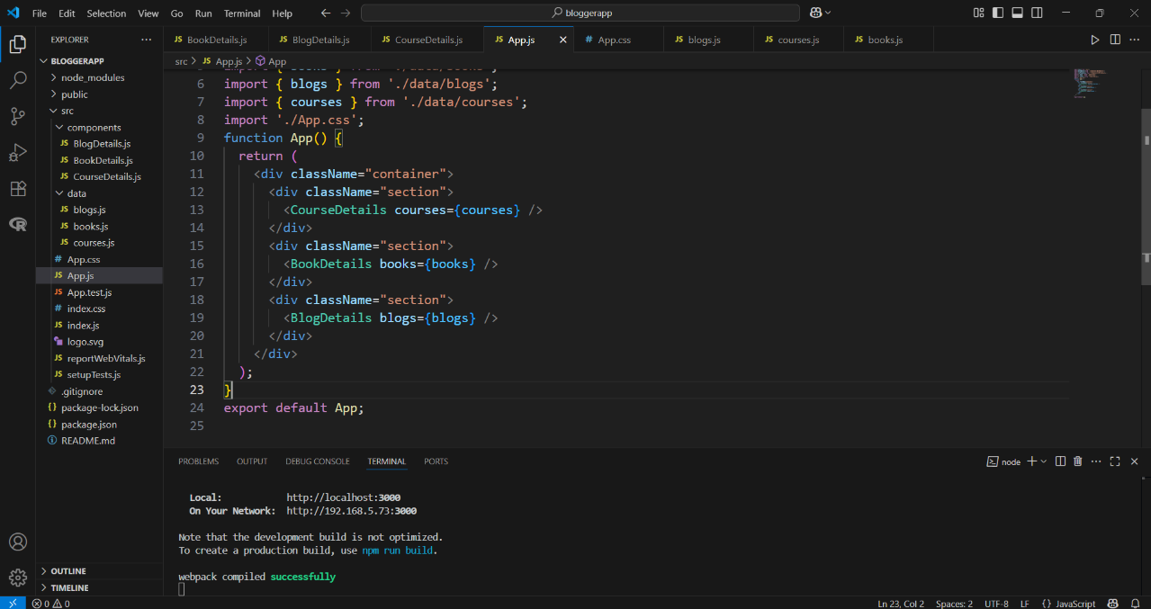

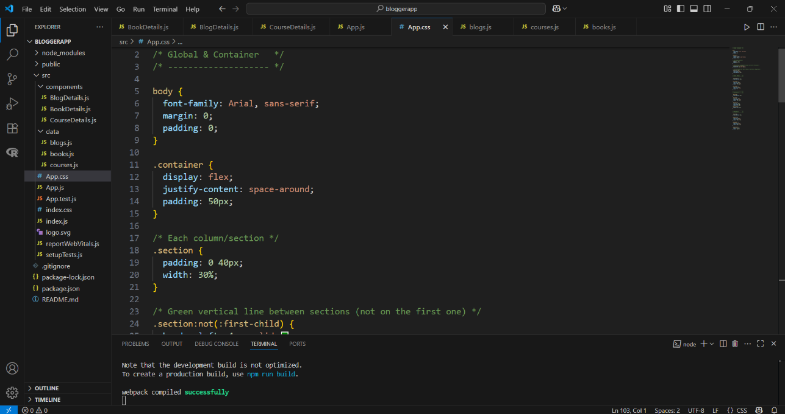
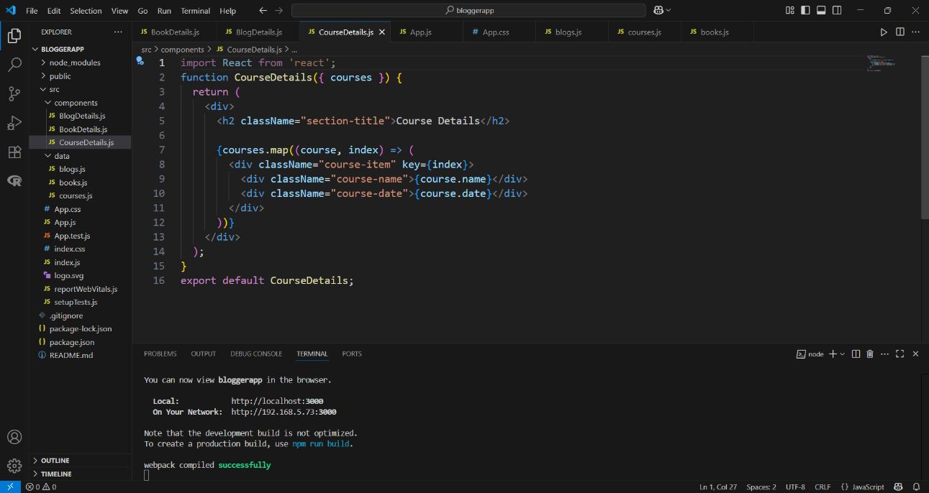

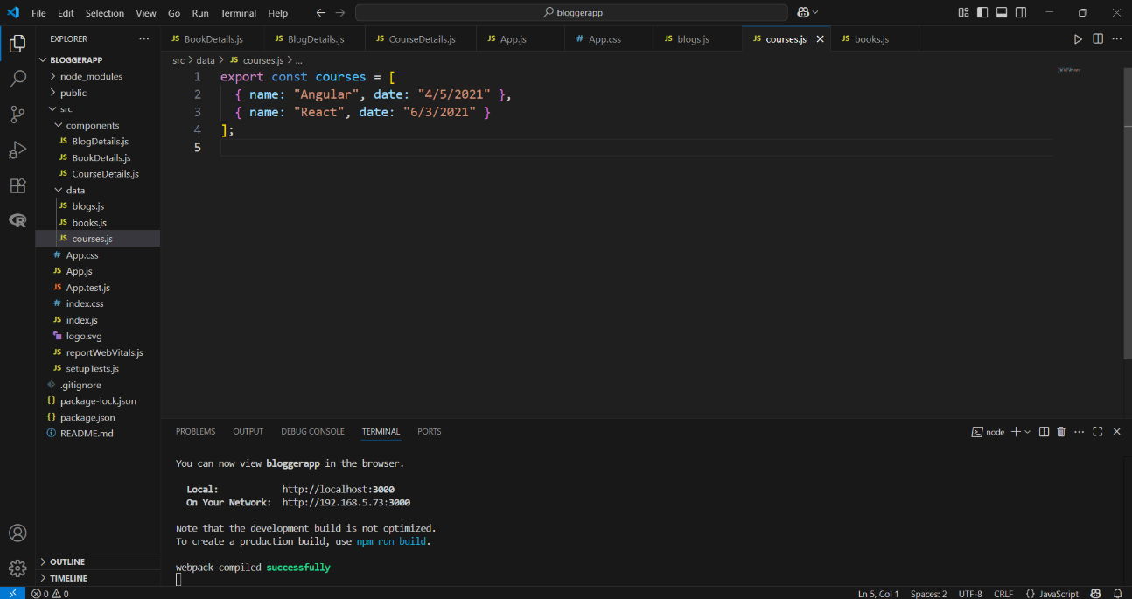

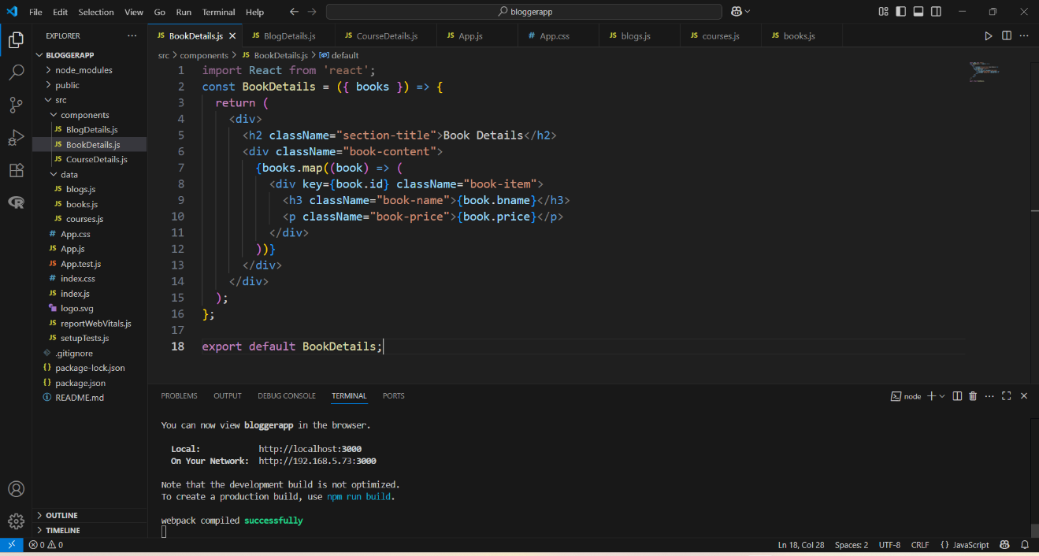

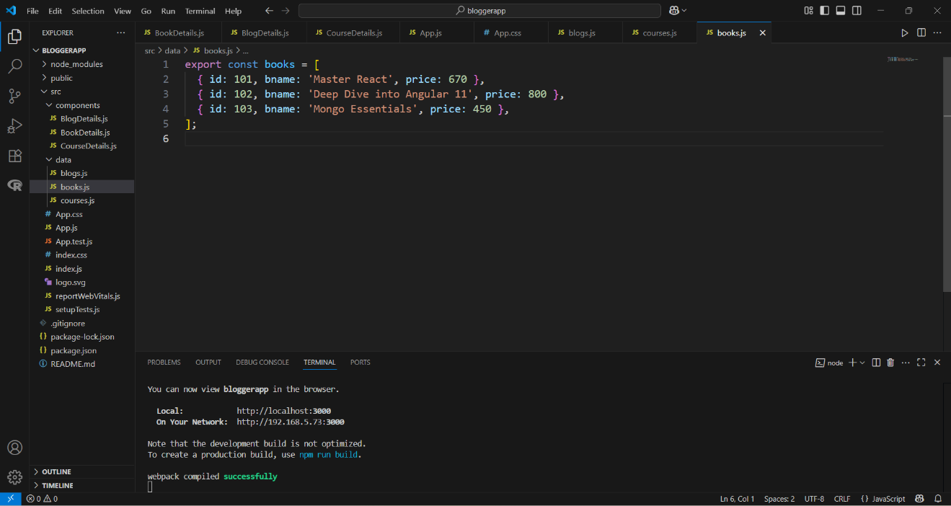

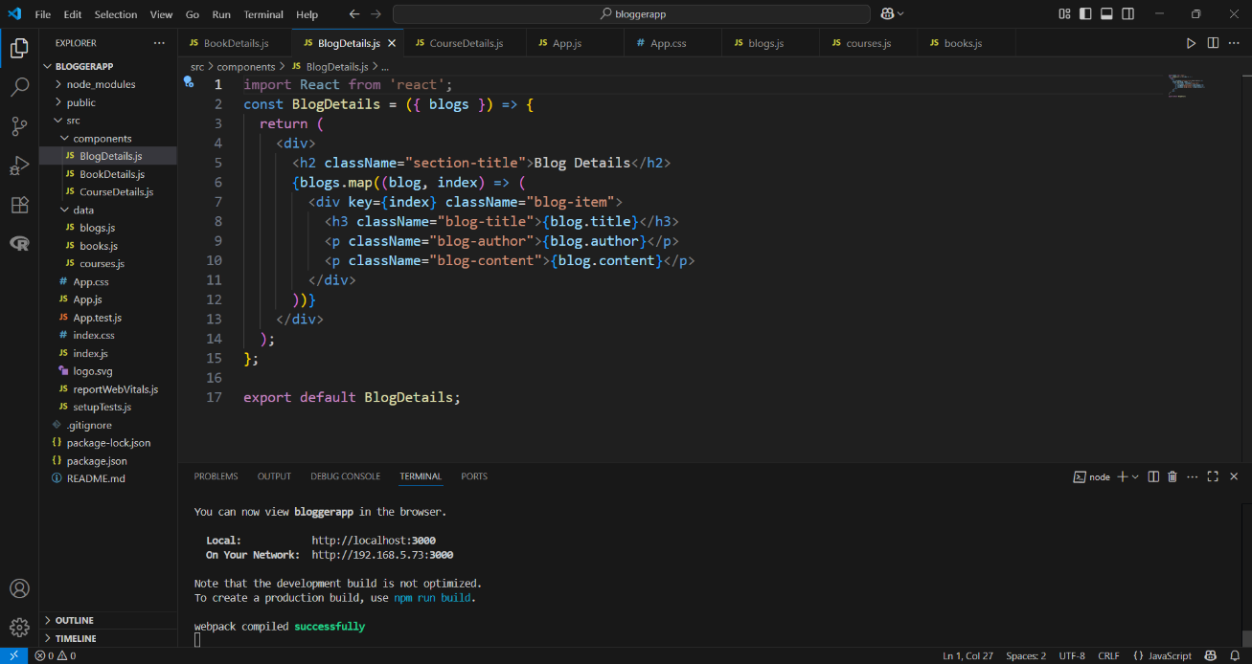

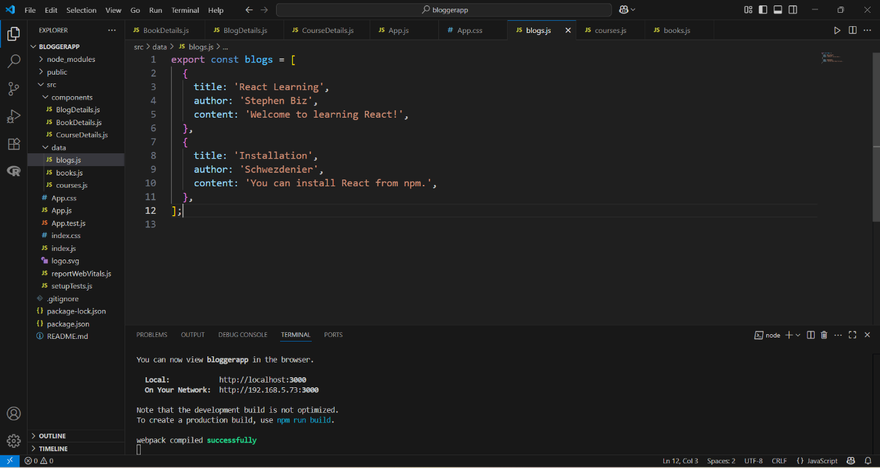

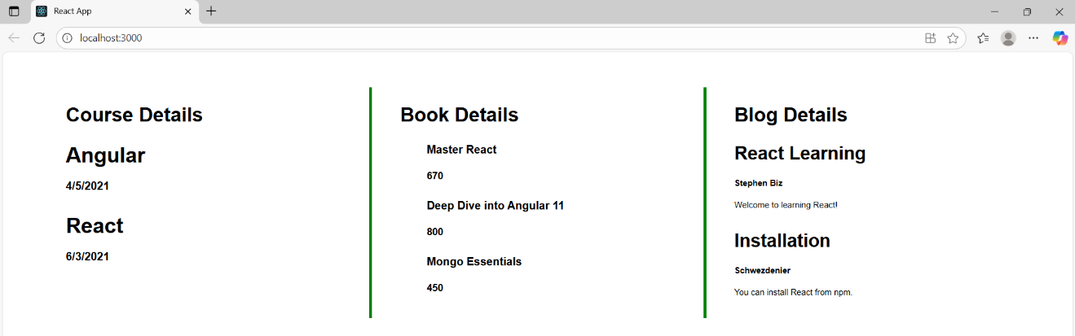

CurrencyConvertor:

CODE:

App.js:

import React, { useState } from 'react';
import CurrencyConvertor from './CurrencyConvertor';

function App() {
const [count, setCount] = useState(1);

const increment = () => {
setCount(prev => prev + 1);
sayHello();
};

const sayHello = () => {
alert("Hello! This is a static message.");
};

const decrement = () => {
setCount(prev => prev - 1);
};

const sayWelcome = (message) => {
alert(message);
};

const handleClick = () => {
alert("I was clicked");
};

return (
<div style={{ margin: '20px', fontFamily: 'Arial' }}>
<h3>{count}</h3>
<div style={{ marginBottom: '10px' }}>
<button onClick={increment}>Increment</button>
</div>
<div style={{ marginBottom: '10px' }}>
<button onClick={decrement}>Decrement</button>
</div>
<div style={{ marginBottom: '10px' }}>
<button onClick={() => sayWelcome("Welcome")}>Say welcome</button>
</div>
<div style={{ marginBottom: '10px' }}>
<button onClick={handleClick}>Click on me</button>
</div>

<CurrencyConvertor />
</div>
);
}

export default App;

CurrencyConverter.js:

import React, { useState } from 'react';
import CurrencyConvertor from './CurrencyConvertor';

function App() {
const [count, setCount] = useState(1);

const increment = () => {
setCount(prev => prev + 1);
sayHello();
};

const sayHello = () => {
alert("Hello! This is a static message.");
};

const decrement = () => {
setCount(prev => prev - 1);
};

const sayWelcome = (message) => {
alert(message);
};

const handleClick = () => {
alert("I was clicked");
};

return (
<div style={{ margin: '20px', fontFamily: 'Arial' }}>
<h3>{count}</h3>
<div style={{ marginBottom: '10px' }}>
<button onClick={increment}>Increment</button>
</div>
<div style={{ marginBottom: '10px' }}>
<button onClick={decrement}>Decrement</button>
</div>
<div style={{ marginBottom: '10px' }}>
<button onClick={() => sayWelcome("Welcome")}>Say welcome</button>
</div>
<div style={{ marginBottom: '10px' }}>
<button onClick={handleClick}>Click on me</button>
</div>

<CurrencyConvertor />
</div>
);
}

export default App;

Outputs:

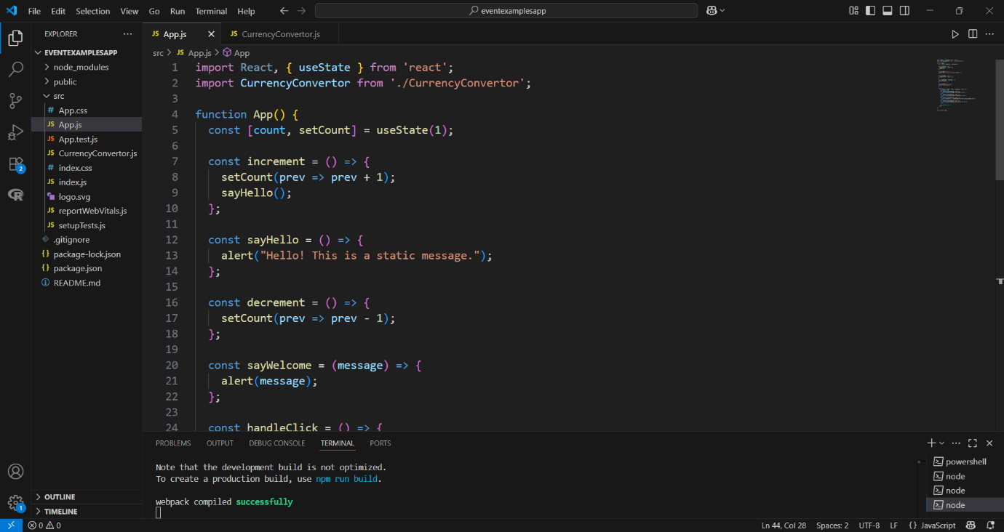

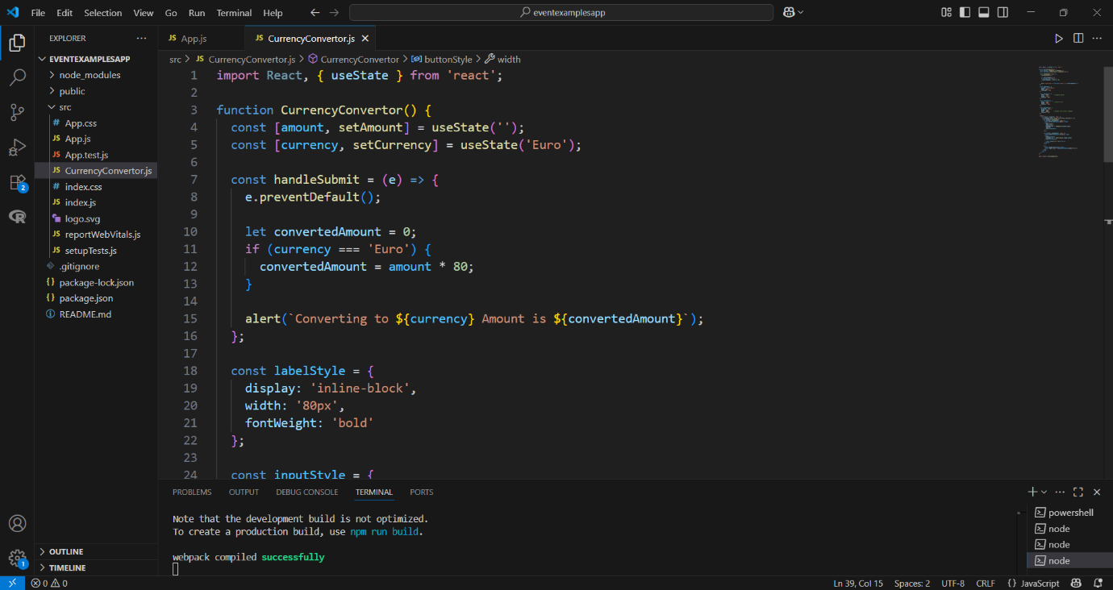

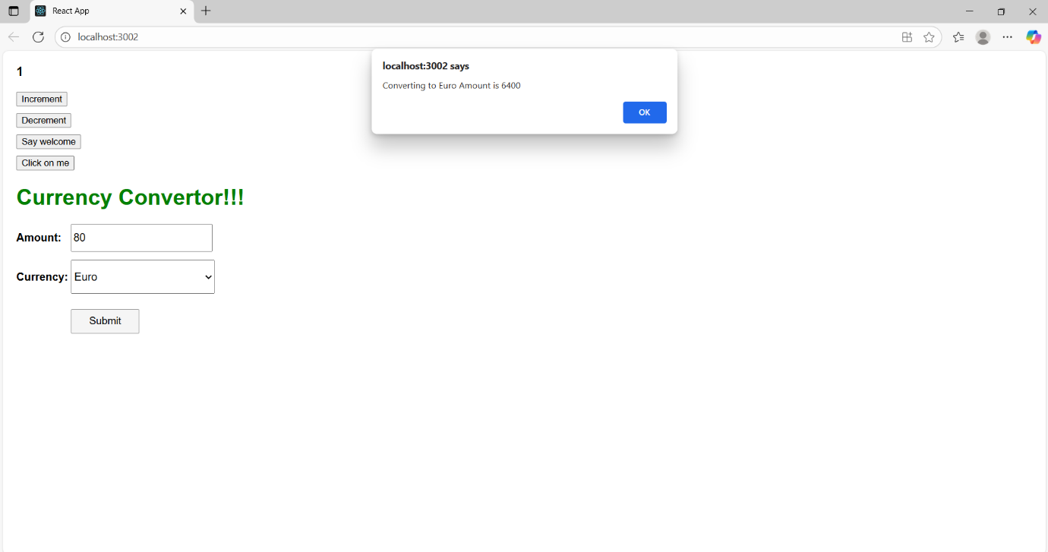

OfficeSpaceRentalApp:

CODE:

App.js:

import React from 'react';
import officeImage from './office.jpg'; // Ensure this image is inside the src folder

function App() {
const officeSpaces = [
{
name: 'DBS',
rent: 50000,
address: 'Chennai'
}
];

return (
<div style={{ fontFamily: 'Arial, sans-serif', padding: '30px' }}>
{/* Heading */}
<h1 style={{ textAlign: 'center', fontWeight: 'bold', fontSize: '30px' }}>
Office Space, at Affordable Range
</h1>

{/* Image and details block */}
<div style={{ marginLeft: '880px', marginTop: '30px' }}>
<img
src={officeImage}
alt="Office"
width="250"
style={{
borderRadius: '10px',
display: 'block',
marginBottom: '20px'
}}
/>

{officeSpaces.map((office, index) => (
<div key={index} style={{ lineHeight: '2' }}>
<h1 style={{ fontSize: '30px', fontWeight: 'bold', margin: '10px 0' }}>
Name: {office.name}
</h1>

<p
style={{
color: office.rent < 60000 ? 'red' : 'green',
fontSize: '22px',
fontWeight: 'bold',
margin: '10px 0'
}}
>
Rent: Rs. {office.rent}
</p>

<p style={{ fontSize: '22px', fontWeight: 'bold', margin: '10px 0' }}>
Address: {office.address}
</p>
</div>
))}
</div>
</div>
);
}

export default App;

App.css:

.App {
text-align: center;
margin-top: 20px;
font-family: Arial, sans-serif;
}

.textRed {
color: red;
font-weight: bold;
}

.textGreen {
color: green;
font-weight: bold;
}

.office-details {
margin-top: 20px;
}

Outputs:

